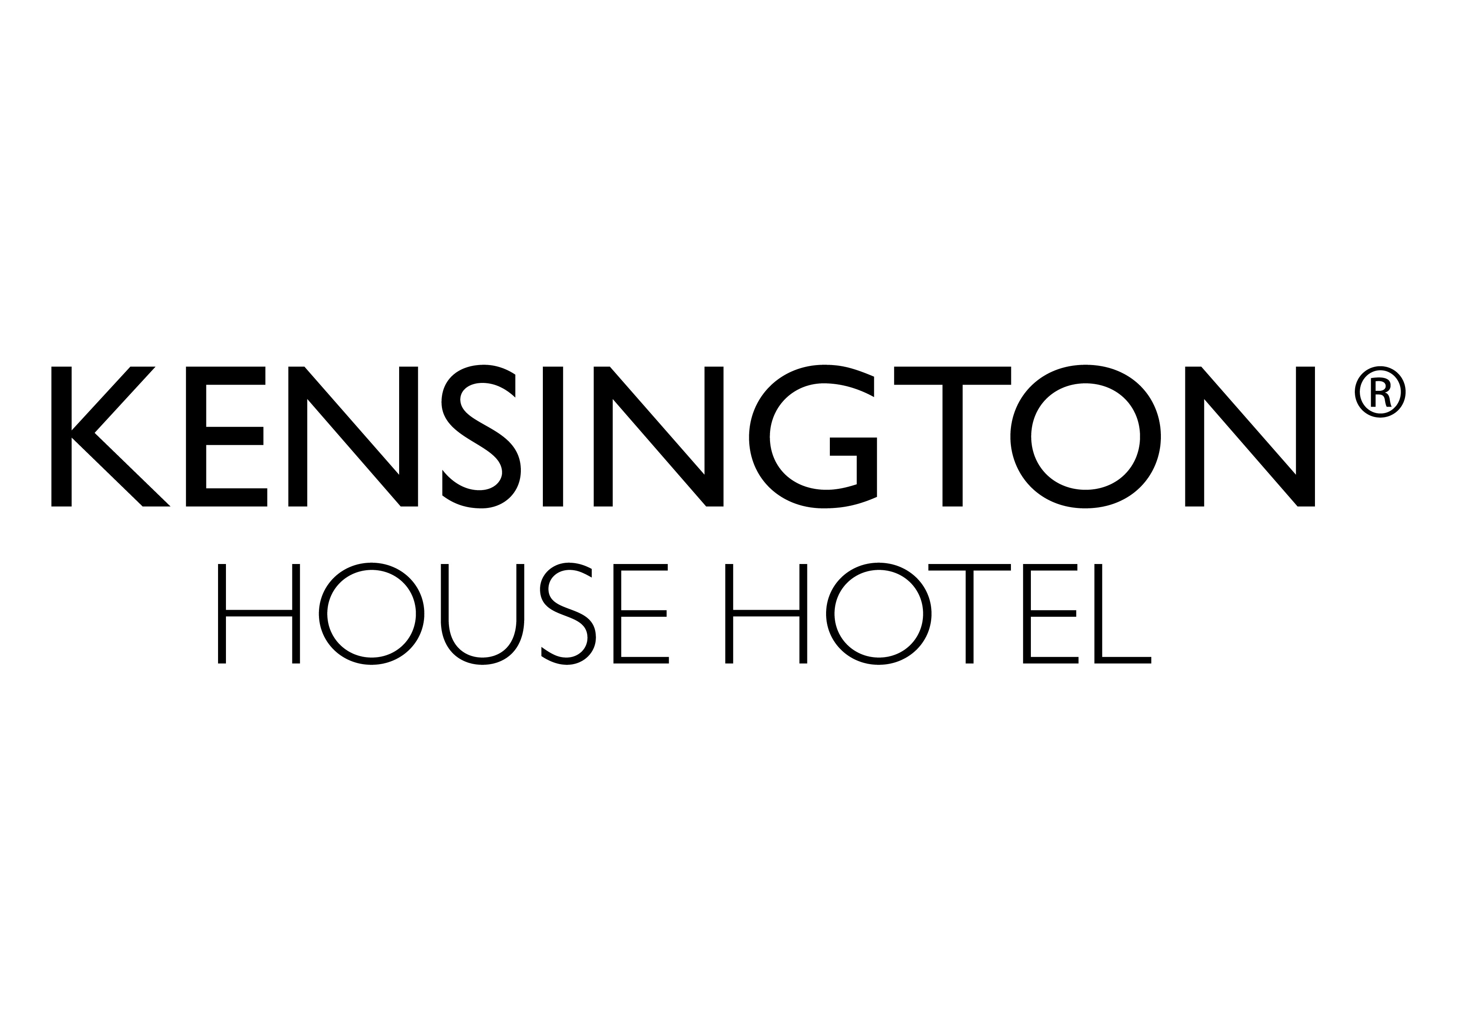
Media Contacts: Melanie Childs/Sue Lowry

Magellan PR
Tel: +44(0)1483 570 804

Email: firstname@magellan-pr.com

Web Adrdress : www.magellan-pr.com

Twitter Address : @MagellanPR

Blog: www. http://magellanstraits.com/

Spring is in the air and London has had a facelift!
London is sprucing herself up for this summer and the London 2012 Festival so now has never been a better time to visit, especially before the crowds hit the streets for the Diamond Jubilee and the London 2012 Olympics.
Kensington Palace re-opened its doors to the public in March after a two year GBP12 Million refurbishment. The Palace original purchased for the princely sum of GBP20,000 in 1689 by William III and Queen Mary and was at the time considered to be an understated residence for such a “powerful” monarch. The palace although out of favour in the royal house hold until Princess Margaret took up residence, was the childhood home of Queen Victoria. For royal watchers, Kensington Palace was the home of the Late Princess Diana and will be the royal residence of Prince William and his wife the Duchess of Cambridge next year. Book your tickets for the palace’s three summer exhibitions Victoria Revealed, Diana - glimpses of a Modern Princess and Jubilee – a view from the crowd. Kensington Palace is only an eight minute walk from Kensington House Hotel.
The Serpentine Gallery is one of London’s best-loved galleries for modern and contemporary art. This year the Serpentine Gallery will open its new space, the Serpentine Sackler Gallery. This innovative arts venue for the 21st century will be within the grounds of Kensington Gardens in the Grade II-listed building formerly known as The Magazine. The gallery has also just announced that Herzog & de Meuron and Ai Weiwei will create the much loved but tempory 2012 Serpentine Gallery Pavilion. It will be the twelfth commission in the Gallery's annual series, the world's first and most ambitious architectural programme of its kind. It’s only open for the summer so don’t miss out! Admission is free and the gallery is only twelve minutes’ walk from Kensington House Hotel.
This summer step out of the wardrobe into the snow as The Lion The Witch and The Wardrobe comes to the stage at The Threesixty Theatre in Kensington Gardens. The outdoor theatre delivers a dynamic theatrical experience and unique facilities. There are over 1480 tiered seats in a circular space, designed to heighten the “buzz” created by the eager audience. The Lion, The Witch and The Wardrobe promises to be every bit as magical as the books, so join Peter, Susan, Edmund and Lucy as they journey through the magical land of Narnia. The Threesixty Theatre and Kensington Gardens are just five minutes by foot from Kensington House Hotel.
Somerset House brings us a season of theatre this May. The World Stages London season is an once-in-a-lifetime celebration of London through theatre. World Stages has been created by eight of London’s leading theatres, collaborating together for the first time to present a season of new shows that draw on the great cultural traditions that make London the most cosmopolitan city in the world. You can also book now for the accompanying World Stages talks. The talks will be on; the Pleasures of Collaboration, Translating Across Cultures and Digital Technology and International Performance.

In honour of Her Majesty the Queen’s Diamond Jubilee, Buckingham Palace presents Diamonds: A Jubilee Celebration. Diamonds have always been synonymous with British royalty, expressing longevity and the magnificence of the British Head of State. This spectacular exhibition at Buckingham Palace will show the many ways in which diamonds have been used by British monarchs over the last 200 years and will include an intimate and personal display of The Queen’s own jewels, outlining her reign for last sixty years. The exhibition opens 30th June until 7th October (please note that Buckingham Palace will be closed from 9th July - 30th July). To book your tickets visit https://www.rceltickets.com/profile.asp. Buckingham Palace is within easy reach from Kensington House Hotel.

A must do if in London this summer is Hard Rock Calling in Hyde Park. This year’s headlining acts are: the newly reformed Soundgarden, the legend Paul Simon and The Boss himself, Bruce Springsteen. This year’s concert in the park will start Friday 13th July, tickets are available at http://www.hardrockcalling.co.uk/news/general/bruce_springsteen_and_the_e_street_band_to_headline_hard_rock_calling_2012. Hyde Park is just twenty minutes from Kensington House Hotel.
The Thames Diamond Jubilee Pageant will take place at high water on the afternoon of Sunday 3rd June. One thousand boats will take to the Thames for Her Majesty the Queen’s Diamond Jubilee Pageant. The pageant will be one of the largest flotillas ever amassed on the river. Boats of all shapes and sizes, whether work horses or pleasure cruisers, will be adorned in their finest patriotic dress, as will their crews and passengers. The “armada” will be supported with passenger boats carrying up to 30,000 members of the public taking pride of place in the middle of the river. Get amongst the festivities, pageantry and celebrations on one on of the many London bridges. There are many bridges within easy reach of Kensington House Hotel. Why not pick your favourite to show your support from.
For reservations and further information please access www.kenhouse.com
ABOUT KENSINGTON HOUSE HOTEL

Kensington House Hotel, a contemporary town house of just 41 rooms, situated on Prince of Wales Terrace within an historic 19th century façade, has taken its place amongst the Kensington set and London’s cognoscenti. Stylish, intimate and friendly, this cool and understated property, which lies just off High Street Kensington, is an oasis of calm amidst the buzz of central London with overnight rates starting at GBP85 inclusive of VAT and breakfast.

This press release is posted at www.magellan-pr.com/press.html

Photos are available upon request

Magellan Public Relations Ltd.: Forty One Church Road, Guildford, Surrey, GU1 4NQ, UK

