Media Contacts: Melanie Childs / Sue Lowry

Magellan PR
Tel: +44(0)1483 570 804


Email: firstname@magellan-pr.com

Web Address: www.magellan-pr.com

Blog: Magellan Straits Blog

Twitter Address: @MagellanPR

Find us on Facebook!

Andrés Araya appointed as Managing Director for
Abadia Retuerta LeDomaine, Spain

Abadia Retuerta LeDomaine is pleased to announce the appointment of Andrés Araya as Managing Director of their new property, near Valladolid, Spain launching on 22nd March 2012.

With more than 20 years’ experience within the hotel industry, most recently at Las Ventanas al Pariso, Los Cabos, Mexico, the Kempinski in Dubai and the Conrad Hotel in Cairo, Araya is delighted with his new role. “I am committed to ensuring Abadia Retuerta LeDomaine becomes known as one of the most important, new destination-lead properties in the world: a luxury hotel estate that will become a ‘must visit’ on the wish list of any discerning global traveller.”

Having led the restoration for the past couple of months on-site, Araya considers himself a custodian of a listed ancient monument and has become immersed into its history. “The Abbey of Santa Maria de Retuerta dates back nearly 1,000 years and we must tread lightly to ensure the correct marriage of modern day convenience with an historical landmark”. To that end, the normal trappings of a hotel are not apparent - there is no reception or concierge desk. Instead, guests are looked after by a team of butlers – the first hotel in Spain to offer a full service.

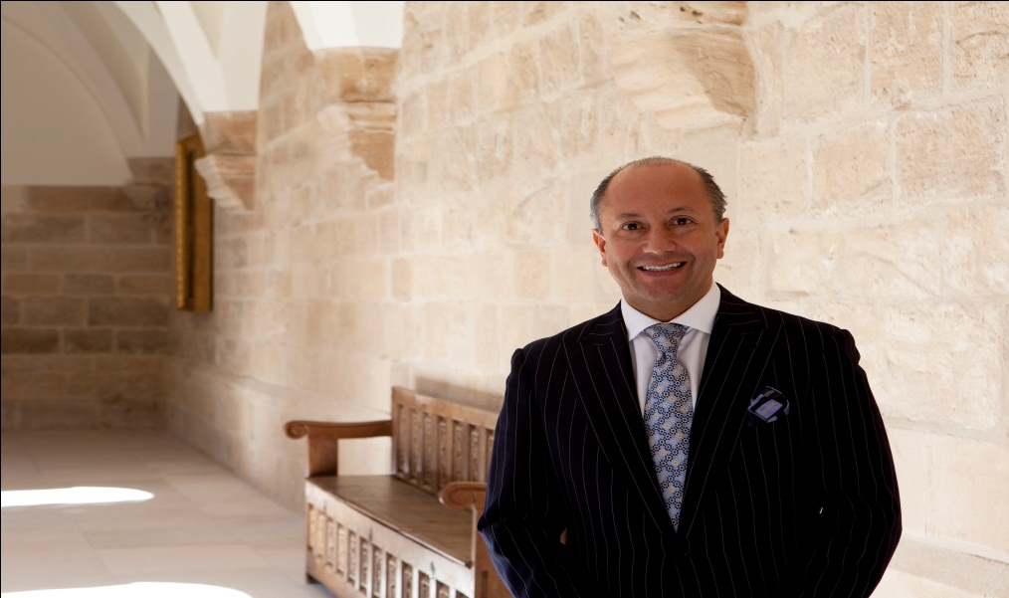

For further information and reservations please visit www.ledomaine.es; contact: info@ledomaine.es or call +34 98 368 0368.
Notes for editors: Abadia Retuerta LeDomaine is an historic medieval Abbey estate of some 700 hectares, located on the banks of the Duero River near Valladolid, Spain. With 22 rooms and suites serviced by a team of butlers, the Refectorio Restaurant serving locally-sourced, gastronomic fare, award winning wines from the renowned Abadia Retuerta winery and meeting rooms accommodating from between 18–200 people, LeDomaine even offers its own outdoor sculpture gallery, The Hedge Museum showcasing works by noted German artist, Ulrich Rückreim.
This press release is posted at www.magellan-pr.com/press.html

Images available on request from Magellan Public Relations.
Magellan Public Relations : Forty One Church Road, Guildford, Surrey, GU1 4NQ, UK

